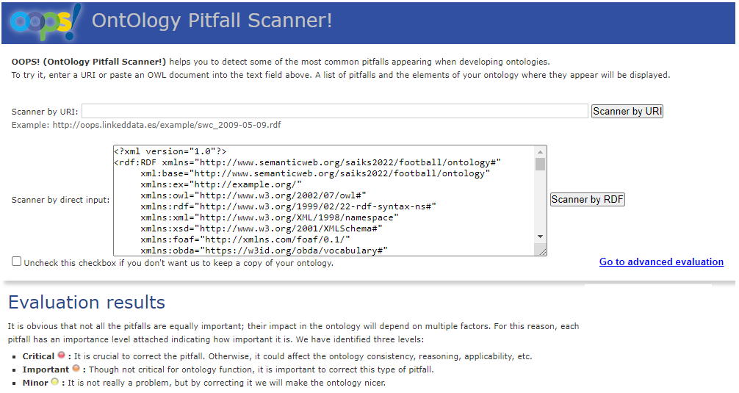

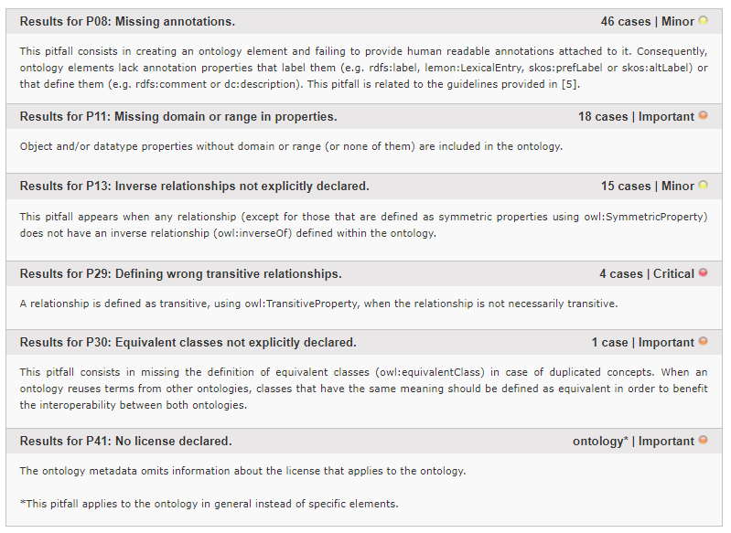

**Important pitfall P41: No license declared.**

**Correction:** The license information of using CC BY-NC-SA license version 4.0 was added to the ontology.

One of the important pitfalls was that the ontology metadata omitted information about the license that applies to our football ontology. To fix it, the license information was added to the ontology, which clearly stated that football ontology is licensed under Creative Commons Attribution-NonCommercial-ShareAlike (CC BY-NC-SA) license version 4.0. In Protégé, the annotation property “dcterms:license” was created and then used to conduct this modification.

https://www.dublincore.org/specifications/dublin-core/dcmi-terms/terms/license/

https://creativecommons.org/licenses/by-nc-sa/4.0/

label: CC-BY-NC-SA 4.0